ĐỀ THI TIẾNG ANH Mã đề: 16
Trình độ A2
Họ và tên thí sinh: ……………..……………………………………………………….……………………………………………………………….
Số báo danh: ……………..…………………………………………...……. Phòng thi số: …………………………….…………………

PAPER TWO LISTENING (Approximately 15 minutes)
PART 1: Questions 1 – 5
You will hear five short conversations. You will hear each conversation twice. There is one question for each conversation. For each question, choose the right answer (A, B or C).
Example: How long was the bus journey?
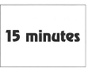
√A □ B □ C □

1. What did Peter do last night?
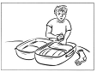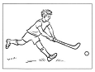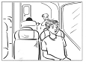
A □ B □ C □
2. What kind of ice scream does the girl buy?
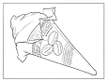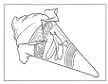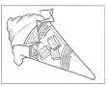
A □ B □ C □
3. What will the weather be like this afternoon?
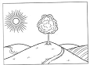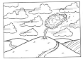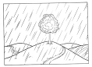
A □ B □ C □
4. Which person is the next new art teacher?
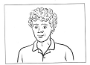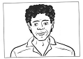
A □ B □ C □
5. What’s the problem with Martina’s snowboard?
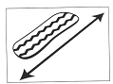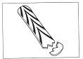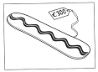
A □ B □ C □

PART 2: Questions 6-10
Listen to Mick asking his uncle about some of his photographs. When was each photograph taken? For questions 6-10, write a letter A-H next to each day. You will hear the conversation twice.
EXAMPLE | ANSWER
0 Bear | B
CLOTHES |  | PLACES
6 cake  7 horse  8 violin  9 boat  10 thunderstorm |  | A Australia  B Canada  C China  D Egypt  E Greece  F Ireland  G New Zealand  H Spain

PART 3: Questions 11-15
Listen to Robert talking to Irena about a new library.
For each question, choose the right answer (A, B, or C). You will hear the conversation twice.
Example: 0. When did the new library first open?
√ A. yesterday
B. two days ago
C. last weekend

11. Robert found out about the library from
A. his grandfather.
B. his cousin.
C. his uncle.
12. Robert thinks the library building is very
A. high
B. dark
C. modern
13. Visitors can look at e-books on
A. the first floor.
B. every floor.
C. the third floor.
14. To join the library, students must take
A. a note from college.
B. a photograph.
C. some money.
15. How far away is the nearest bus stop?
A. less than 100 metres
B. about 150 metres
C. more than 200 metres

